**SQL ASSIGNMENT**

**CustomerHeader Table**

***Queries Screenshot***

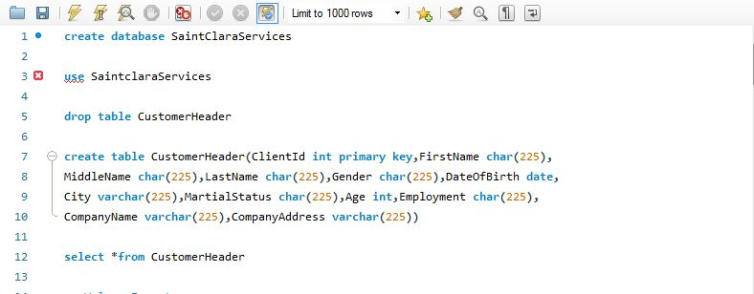

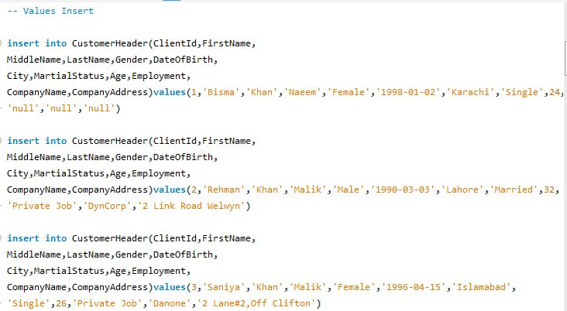

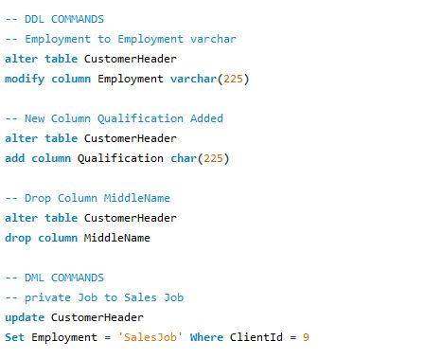

***Table Screenshot***

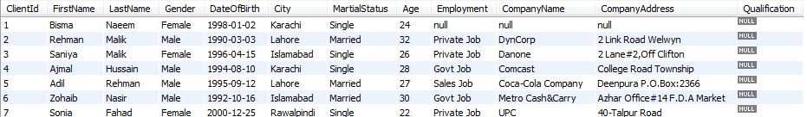

**CustomerDetails Table**

***Queries Screenshots***

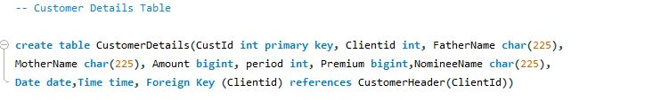

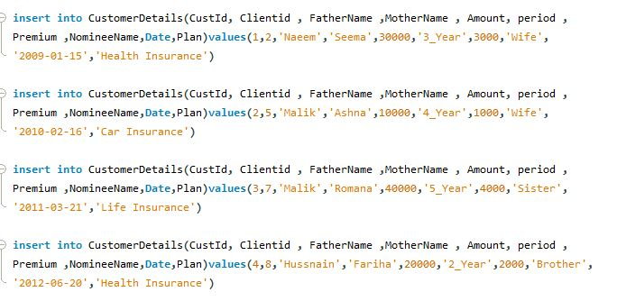

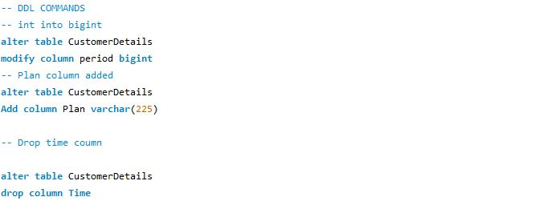

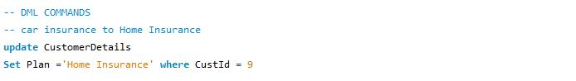

***Table Screenshot***

